**Online Shopping for Indian Saree**

Saree is the most versatile and Lovely Indian Dressing of all time. It hugs the body in such a way that it outlines the body in an appealing way and cover any flaws. When a Ladies wants to go for a saree, there are no age bars as it is best for everyone.

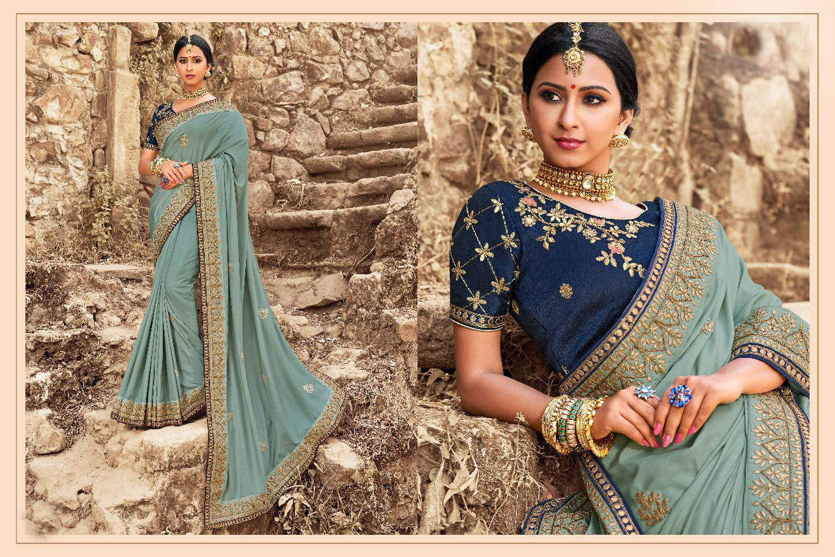

Also, there is nothing as traditional and elegant as saree, it adds attraction and shine to your whole look. Major and Minor types of saree are below :

* Partywear saree
* Designer saree
* Silk saree
* Printed saree
* Wedding saree
* Georgette saree
* Bridal saree

**Latest New Designer Party Wear Sarees**

[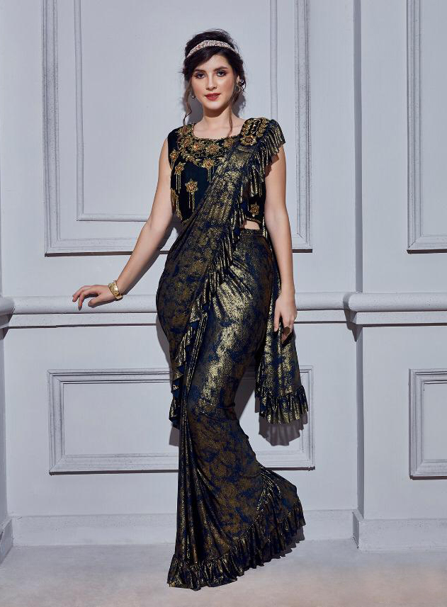](https://www.pavitraa.in/Designer/Saree/All-Saree/Partywear-saree)

Party wear Saree is an ethnological style premier for each women A Saree is the absolute embodiment of ethnic shape. A fancy party wear Saree will make you not purely look rich, but alternatively feel grand as well. Navy Blue Designer party Wear Give stylish Look For Party, Bollywood Event. [latest new designer party wear sarees](https://www.pavitraa.in/Designer/Saree/All-Saree/Partywear-saree) Available on Pavitraa Fashion.

**Latest designer sarees Online For Women**

[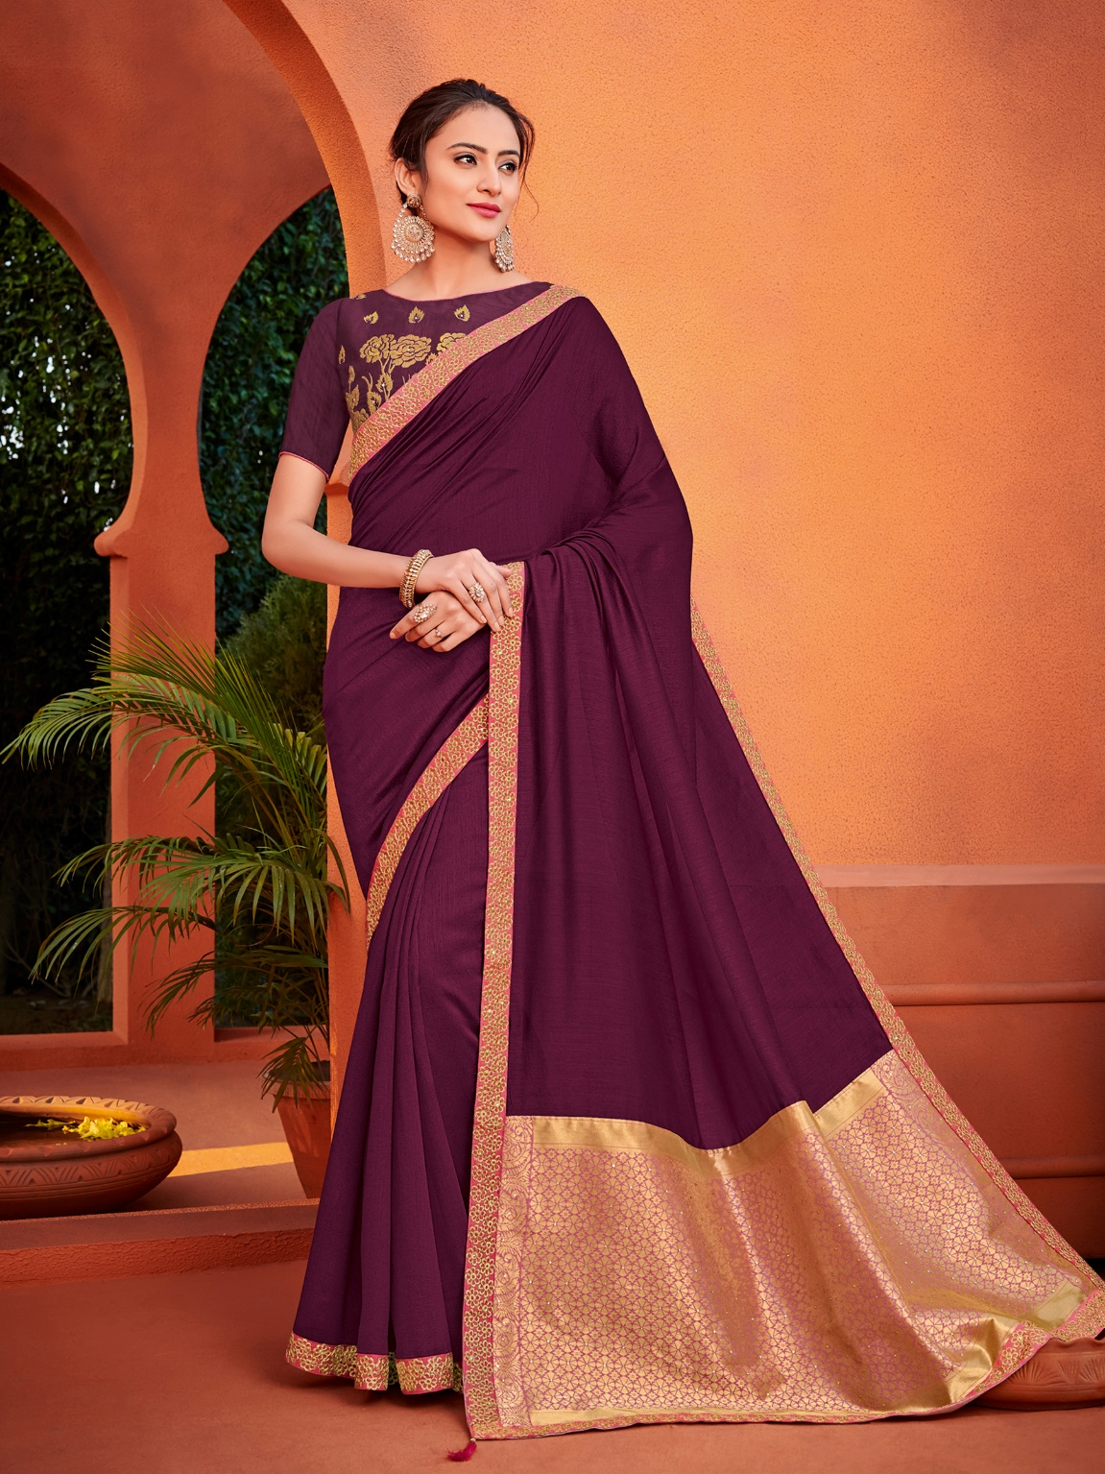](https://www.pavitraa.in/Designer/Saree/All-Saree/Partywear-saree)

Designer sarees are much-loved fashion necessary, adored by fashionistas and celebrities. Now you can get your hands on an unbelievable collection of grand ethnic apparel with Pavitraa’s exclusive collection of designer sarees online. [Latest designer sarees online for Women](https://www.pavitraa.in/Designer/Saree/All-Saree/Designer-saree) available on Pavitraa Fashion. Wine Color Designer Saree gives you that traditional and festive look during Special Occasion.

**Traditional Silk Saree Collection On Pavitraa**

[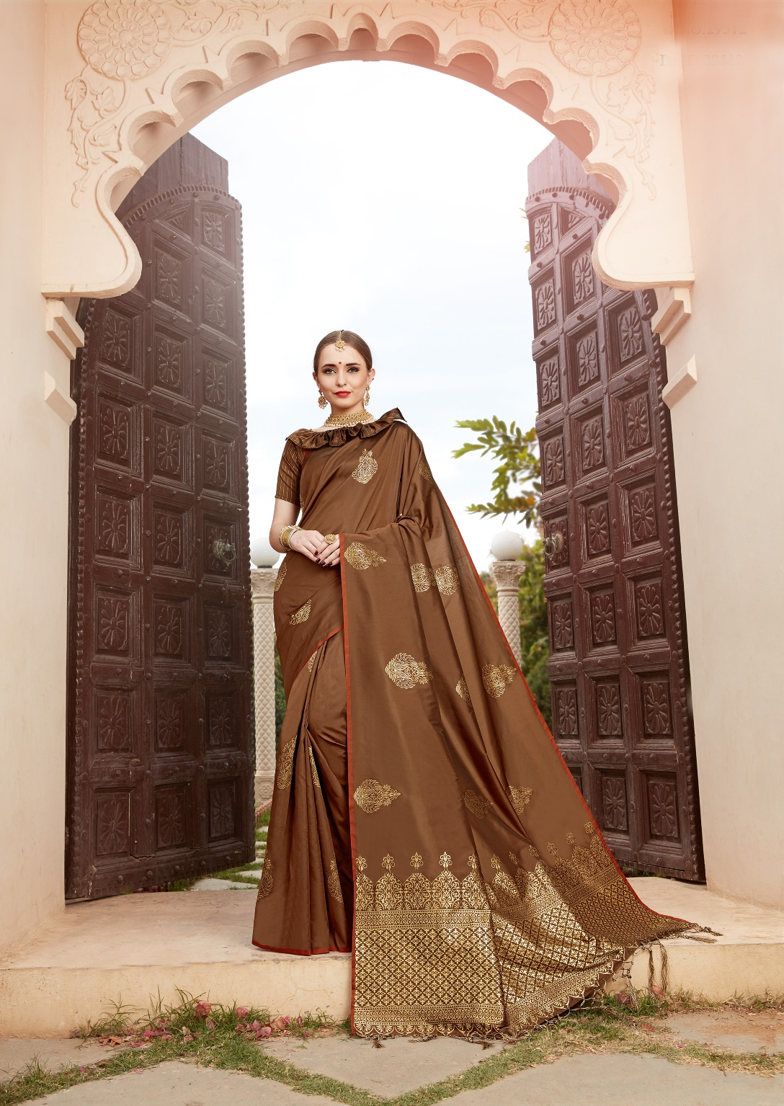](https://www.pavitraa.in/Designer/Saree/All-Saree/Partywear-saree)

No occasion or Festival is complete without a silk saree. Whether it is a heavy kanjivaram silk saree or a light weight Uppada, Silk sarees are the best selection for a bright look. Some of the most Famous Indian silk sarees are the Banarasi Silk, Tussar Silk, Mysore Silk, Bhagalpuri Silk and Art Silk sarees

**Printed Sarees Online Collection**

[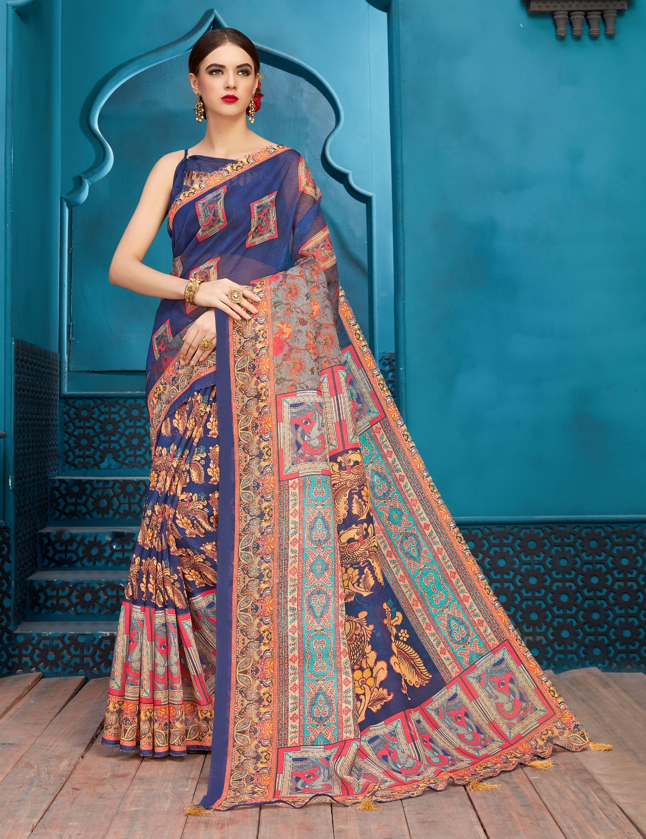](https://www.pavitraa.in/Designer/Saree/All-Saree/Partywear-saree)

A printed saree is an easy Seelction for subtle, as well as style dressing. While you have decide to buy printed sarees online, we make sure that you witness an comprehensive collection here. At pavitraa Fashion, we have the most dynamic scope of printed sarees in a variety of fabric. Blue Printed Casual Wear Saree for OfficeWear. [Buy Printed Sarees Online](https://www.pavitraa.in/Designer/Saree/All-Saree/Printed-saree) Available on Pavitraa Fashion.

**Latest Wedding Sarees Collection**

[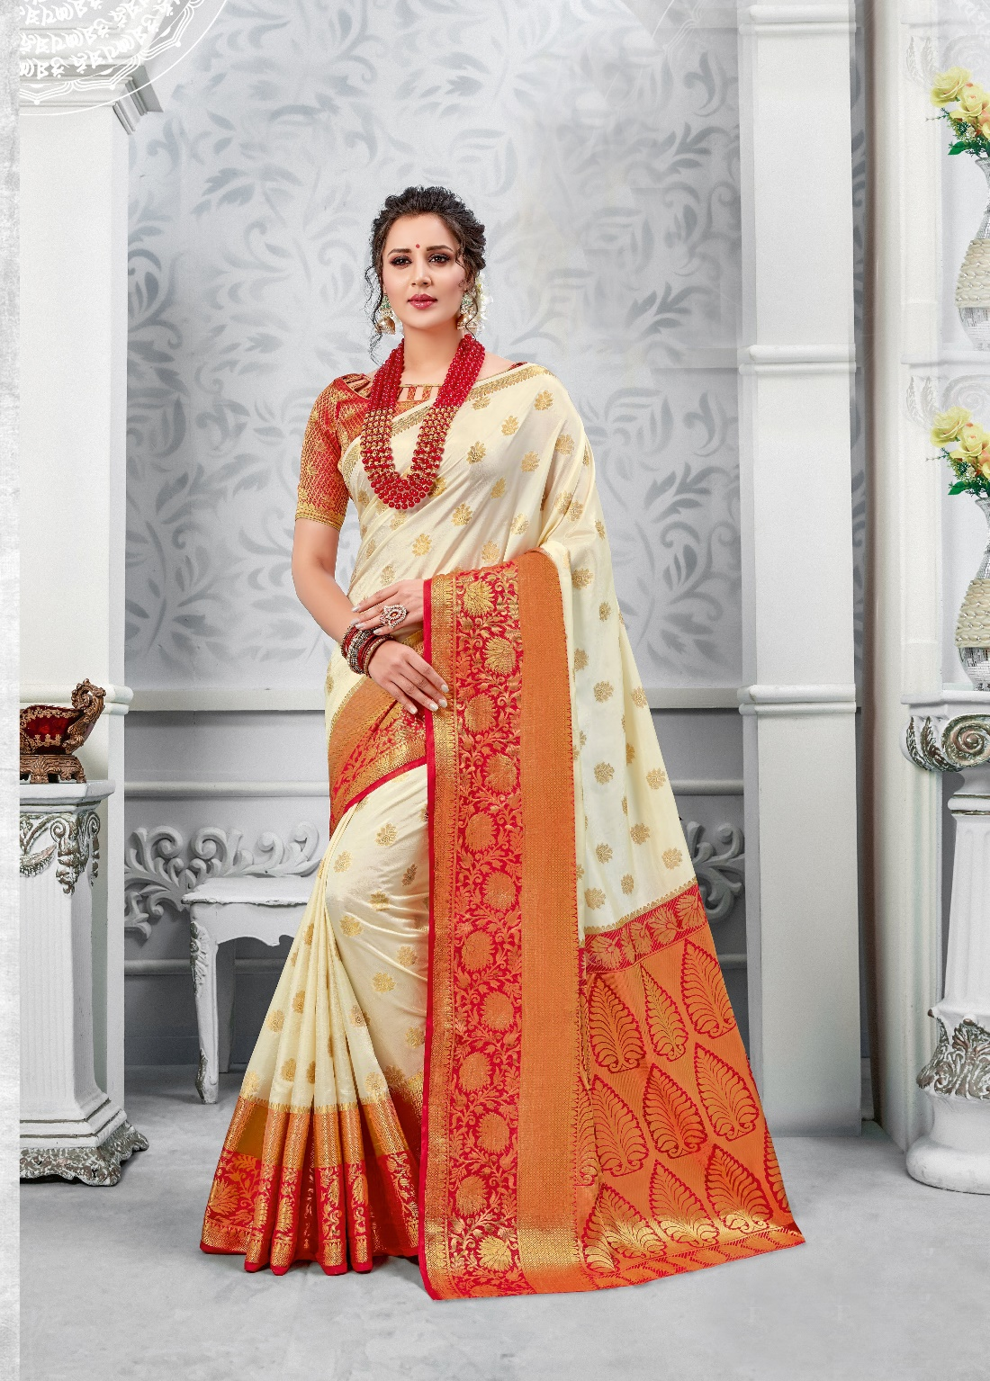](https://www.pavitraa.in/Designer/Saree/All-Saree/Partywear-saree)

A wedding saree is the traditional wedding dress of Indian Ladies. The saree is traditionally red, with golden embroidery. Wedding sarees online Available on pavitraa Fashion. Off White and Red Wedding wear saree give tredy look on every occasion.

**Georgette Saree Collection Online**

[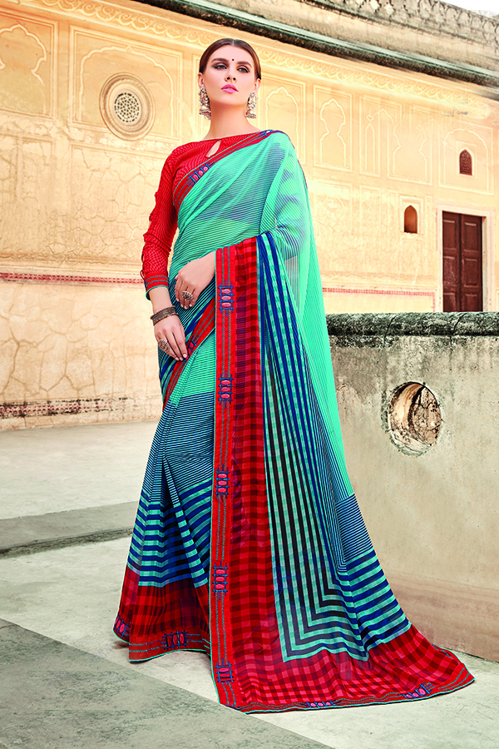](https://www.pavitraa.in/Designer/Saree/All-Saree/Partywear-saree)

Georgette Sarees are also light weight clothes made from silk with highly twisted yarns. These sarees are make in solid colors and prints. Designer Georgette Sarees Give Stylish Look for daily wear.

**Why sarees are the Better outfit for every occasion?**

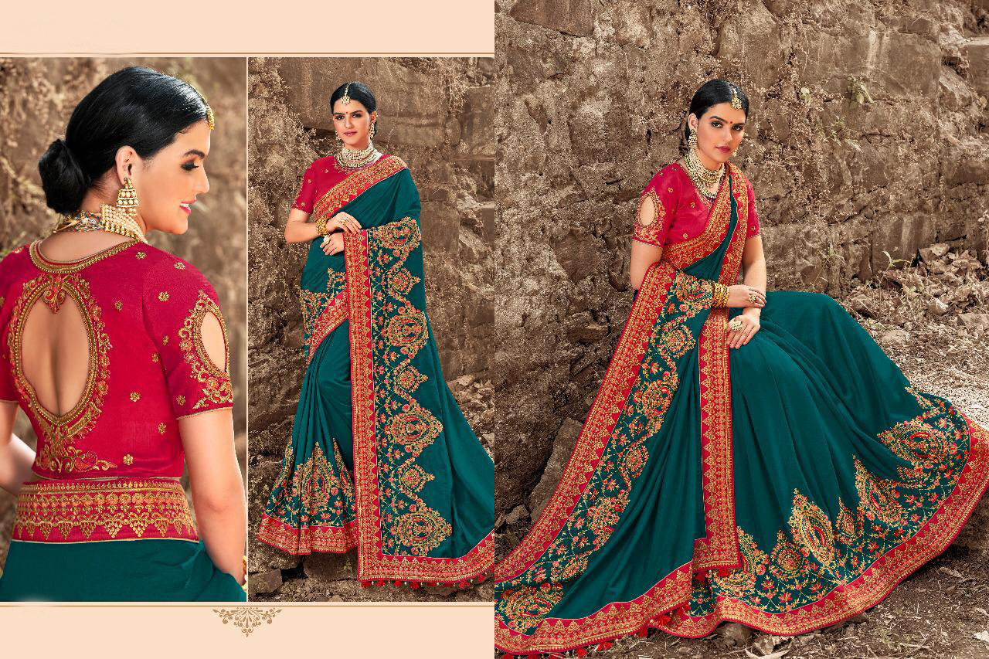

Sarees, being comfortable and elegant at the same time, are the number one selection for every Indian woman. They come in a variation of textures, colors, embroidery& fabrics that leaves one with no better choice than adorning these beautiful pieces of grace.

**For More Please Visit :** [**Best Sarees Online Shopping**](https://www.pavitraa.in/Designer/Saree)